CT2003 Report
Internship Placement Management System

Declaration of Original Work for CT2003 Assignment
We hereby declare that the attached group assignment has been researched, undertaken, completed, and submitted as a collective effort by the group members listed below.
We have honoured the principles of academic integrity and have upheld Student Code of Academic Conduct in the completion of this work.
We understand that if plagiarism is found in the assignment, then lower marks or no marks will be awarded for the assessed work. In addition, disciplinary actions may be taken.
Name | Course | Lab Group | Signature / Date
LWIN MOE OO | CT2003 | 5 | 
MUHAMMAD FIRDAUS BIN KAMARUDIN | CT2003 | 5
MURPHY WONG KAH LEONG | CT2003 | 5 | 
PANG WEI JIE | CT2003 | 5
PAZHANISAMY HARISH PRABHU | CT2003 | 5 | 

Important notes:
1. Name must EXACTLY MATCH the one printed on your Matriculation Card.
2. Student Code of Academic Conduct includes the latest guidelines on usage of Generative AI and any other guidelines as released by NTU.

1. Design Considerations 2
2. Approach 3
3. OODP Principles 4
3.1. Abstraction 4
3.2. Polymorphism 4
3.3. Inheritance 5
3.4. Encapsulation 5
3.5. Exception handling 5
4. SOLID Design Principles 6
4.1 Single Responsibility Principle 6
4.2 Open-closed Principle 6
4.3 Liskov Substitution Principle 7
4.4 Interface Segregation Principle 8
4.5 Dependency Injection Principle 9
5. Assumptions 10
6. UML Class Diagram 11
7. Testing/Test cases and results 11
8. Reflection 13

1. Design Considerations
- Create a superclass named User for all three types of users; students, career centre staffs and company representatives. This makes future changes easier without affecting other parts.
- All users must be able to change to a new password and new password to be stored in a CSV file.
- All users must be able to view internship list.
- Students can view the internship list and apply for internship. The application needs to be reviewed by company representatives.
- Career centre staff can review the company's registration and view internship opportunities created by company representatives.
- Company representatives can create internship opportunities and review students’ internship applications.
- Implement Enum class for special attributes type.
Architectural Approach
The assignment adopts the Boundary-Control-Entity (BCE) pattern, reinforced by additional design patterns such as Command, Strategy and Repository.
Layer | Responsibilities | Examples
Boundary (UI / I / IO) | Handles console input/output and file operations | team5.boundaries:  - ConsoleBoundary  - CsvFileBoundary  - InternshipBoundary  team5.interfaces.FileBoundary, team5.filters:  - InternshipFilter  - InternshipFilterCriteria  - InternshipFilterPrompt
Control (Logic) | Coordinates application flow and user actions | team5.controllers:  - StudentController  - CareerCenterStaffController  - CompanyRepController  team5.registration. CompanyRepRegistrationHandler:  - team5.studentactions  - team5.staffactions  - team5.companyrepactions
Entity | Represents business objects and data | team5.package:  - User  - Student  - CareerCenterStaff  - CompanyRep  - Internship  - InternshipApplication  team5.enums:  - UserType  - UserAccountStatus  - InternshipLevel  - InternshipStatus  - CSVType

2. Approach
- Identify core functionalities and create flowcharts for different user types.
- Create UML class diagrams stating the attributes and methods, to visualise relationships between entities.
- Each of the team members in charge of different parts of the internship system integration.
- Activity diagram to recognise the design of the program flow and structure
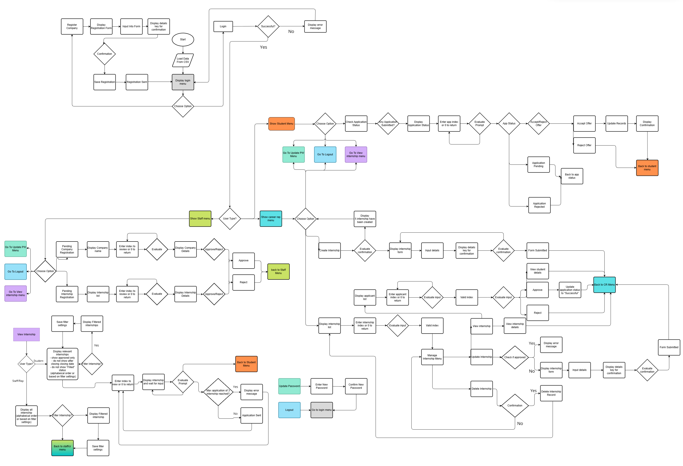
- Used task planner in Microsoft Teams for tracking of implementation progress.
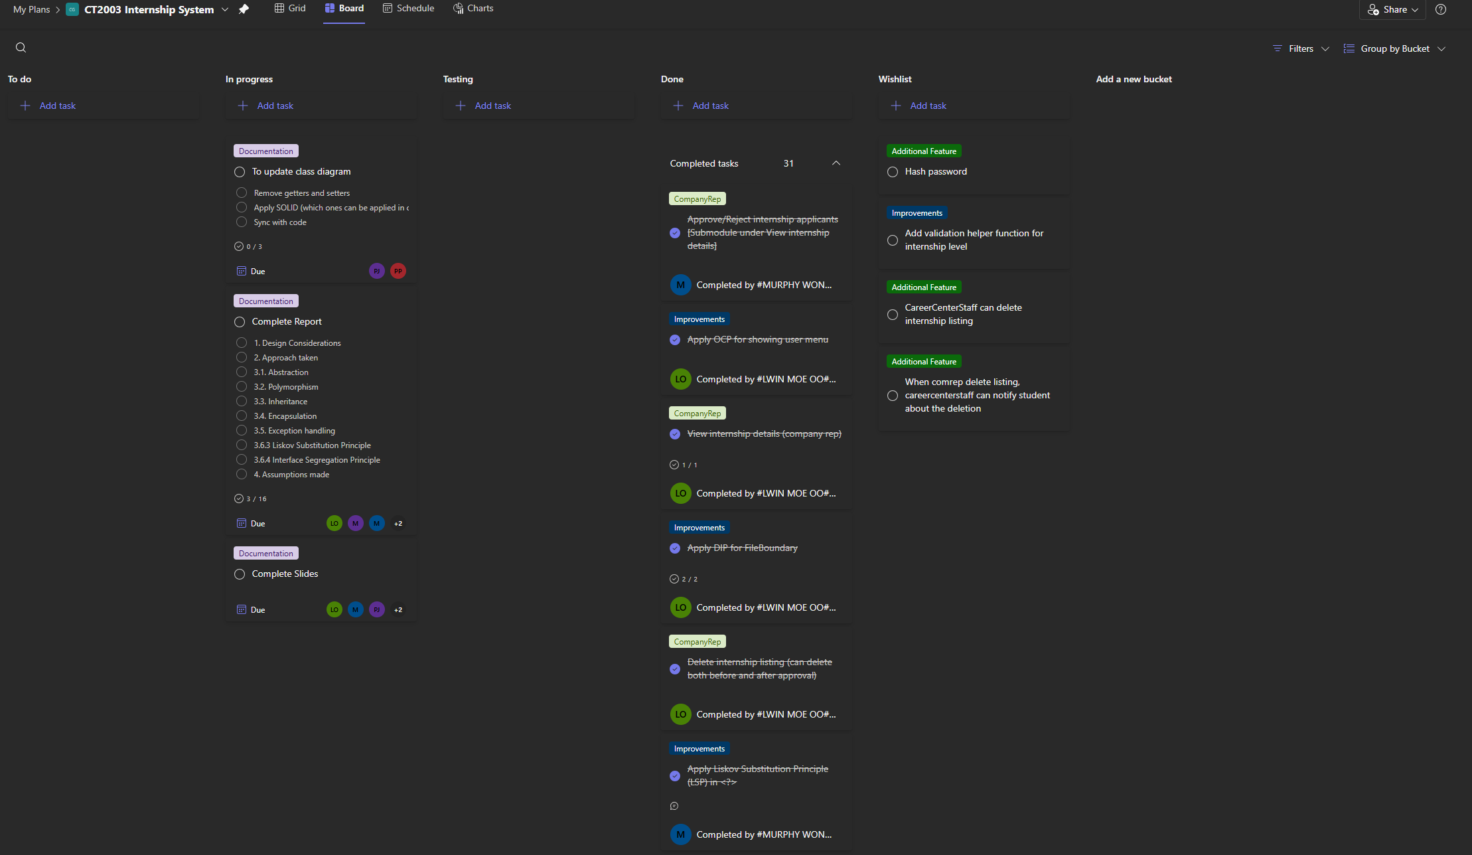

3. OODP Principles

3.1. Abstraction
- Data Abstraction
  - Example: Each object data is not visible to outer world, use setter and getter method to access them.
- Process Abstraction
  - Example: Hide the internal implementation of each object function / operation. The user only needs to provide input of what they wanted to do.
- Abstraction is achieved through a generalised User superclass that defines attributes (userID, name, email, password) and shared behaviours (Login, Logout, ChangePassword).
- Concrete subclasses (Student, CareerCenterStaff, CompanyRep) extend the base class and specialise role-specific data and actions.
- All databases are managed and updated by backend. User will not need to save the record manually. They just need to view, review, accept offer etc.

3.2. Polymorphism
- printSectionTitle method has overloading of different input parameters.
- Included override toString method in Student, CareerCenterStaff and CompanyRep class.
- Runtime Polymorphism: We overrode the toString() method in all User subclasses to provide role-specific profile displays. Additionally, the login() method behaves differently for CompanyRep (who checks for an “Approved” status) compared to Student.
- ​Interface Polymorphism: We implemented a FilterStrategy interface. Different classes (FilterByMajor, FilterByDate) implement this interface, allowing the Controller to swap filtering logic dynamically based on user selection.
- Controllers invoke methods through polymorphic references. Eg: showMenu() is implemented differently across controllers (StudentController, CareerStaffController, CompanyRepController) by inheriting from the abstract UserController class. This allows runtime behaviour changes based on user type.

3.3. Inheritance
- User class and subclasses such as Student, CareerCenterStaff and CompanyRep
- Interfaces and concrete class that implements the methods specified in the interfaces.
For e.g.: Subclasses reuse base identity and added role-specific behaviour (Student, CareerCenterStaff and CompanyRep)
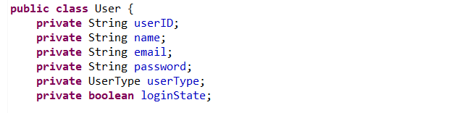
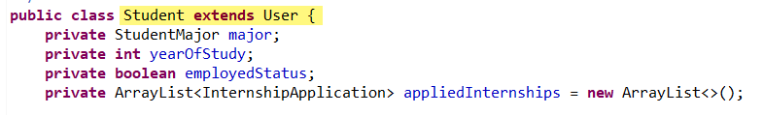

3.4. Encapsulation
- Helper methods to save and load CSV
- Use setter and getter to prevent direct modification to class attributes.
- Separate actions done by each user by creating separate class.
- Each user and their actions are encapsulated to a separated class.
For e.g.: fields are private, but updates happen through methods, where you can add validation without exposing the internals.
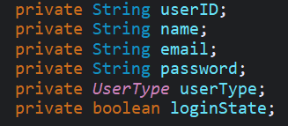
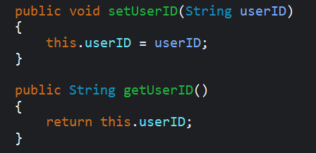

3.5. Exception handling
- Try-catch blocks in App.java to prevent program crash caused by invalid input from user.
- Detailed print message when user choose or enter wrong input.
- Handle file operation exceptions.
For e.g.: Guarding I/O with checked exceptions and surfacing messages via the boundary.
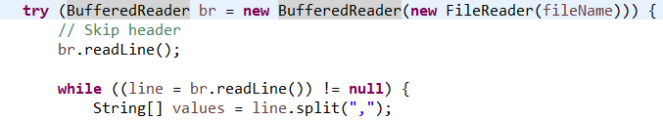
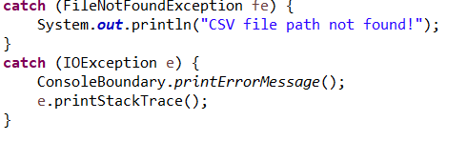

4. SOLID Design Principles

4.1 Single Responsibility Principle
Before: The internship list filter feature for viewing internship, is encapsulated in a single method, which is including print the filter selection page, prompt the user to select filter type, and apply the filter to original internship list. This has violated SRP as the method is having multiple responsibilities.

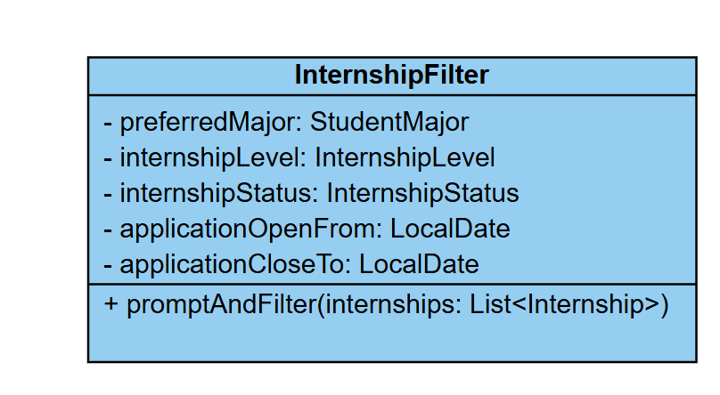
After: The internship list filter feature has been separated to a few different classes, which handles different tasks of filter such as prompt user to select the filter type and applying the selected filter criteria to the internship list.
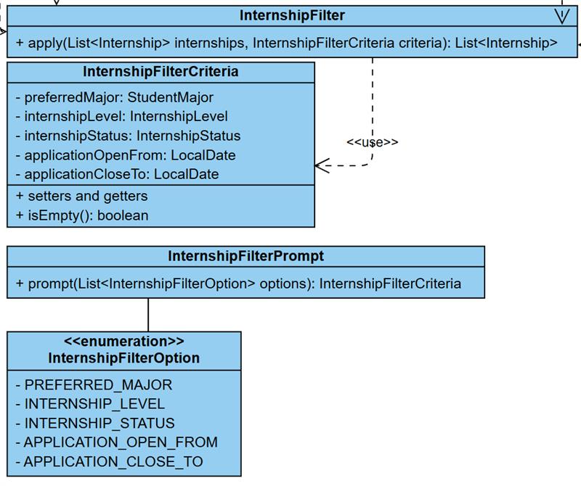

4.2 Open-closed Principle
E.g. Extends for a new user type: Admin
Before | 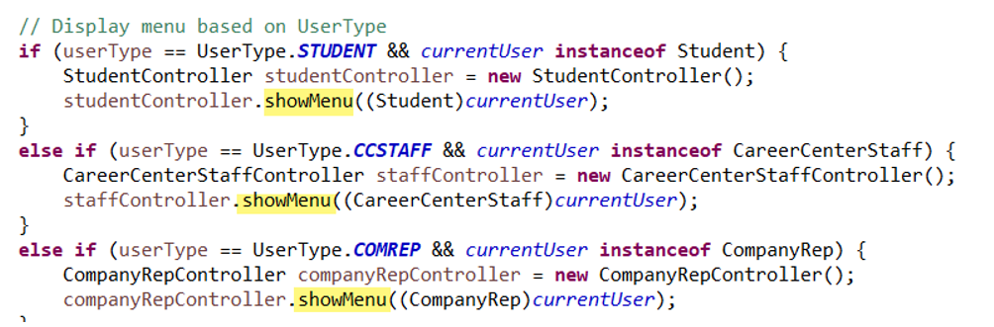  When there is a new user type, we need to modify the implementation to cater for the new user type.
After | When there is a new user type, we just need to create a new class and controller without modifying the implementation.

4.3 Liskov Substitution Principle
Objects of a superclass should be replaceable with objects of its subclasses without affecting the correctness of the program.
Example: User Derived User Class**
Implementation file: InternshipSystem/src/team5/User.java
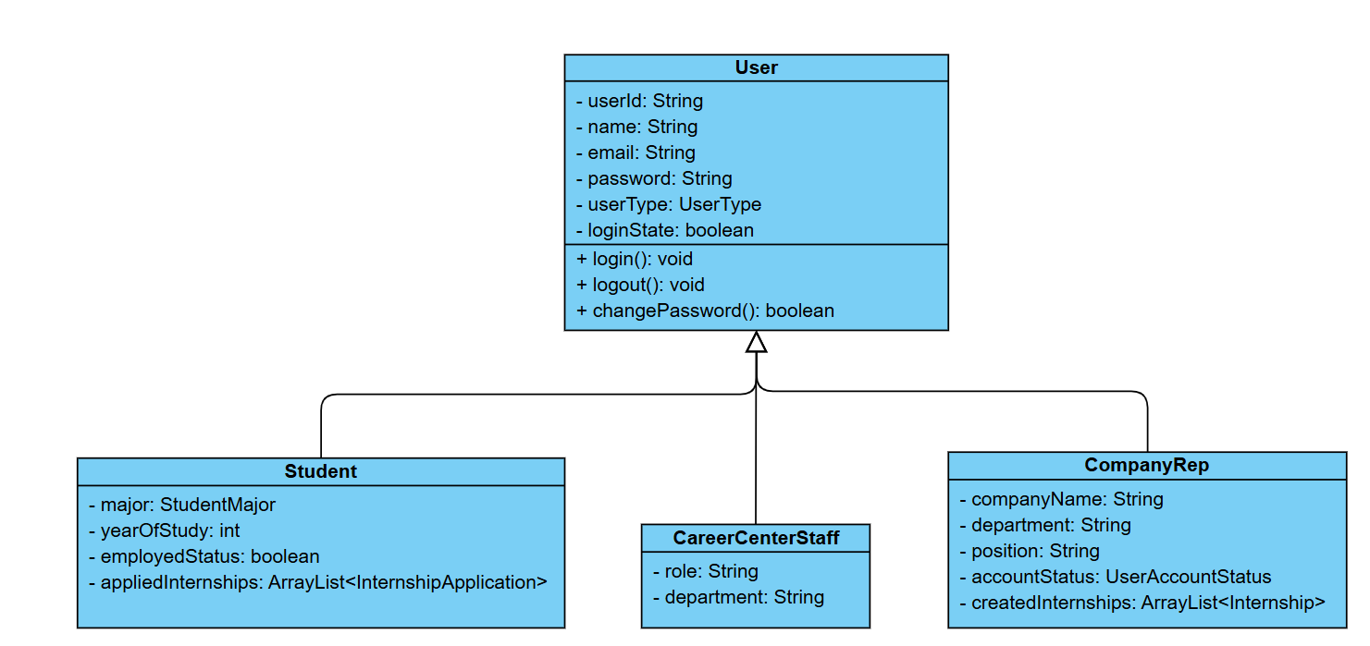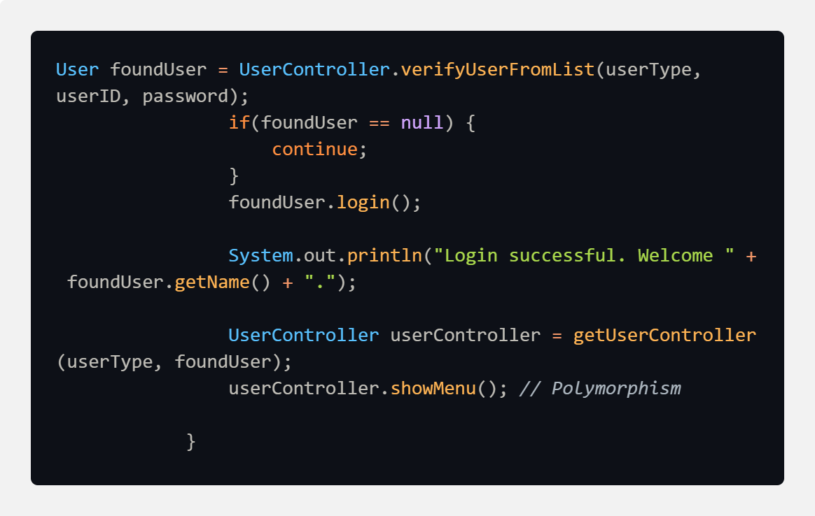

4.4 Interface Segregation Principle
- Don’t make large, “fat” interfaces that include methods not relevant to all classes that implement them.
- Instead, create smaller, more specific interfaces — so each class only needs to implement the methods it uses.
Example:
Before: Classes implementing CSVRepository will have to handle all 4 methods when using it. This forces implementing classes to include methods that we may not need, hence violating ISP.
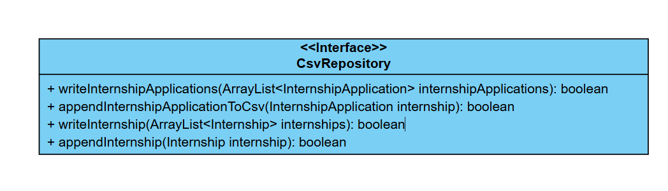
After: The proposed design changes refactor it into 2 separate interfaces: 1 to handle internship and the other to handle internship applications. This enforces each class only have depends on the method it is using, which aligns with ISP.
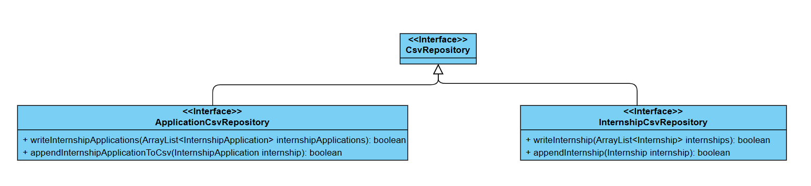

4.5 Dependency Injection Principle
Usage of FileBoundary concrete class in CreateInternshipAction.java
Before | Initialise the fileBoundary object using FileBoundary concrete class  private final FileBoundary fileBoundary = new FileBoundary();  Usage  boolean isSuccessful = fileBoundary.appendInternshipToCsv(internship);
After | Initialise the fileBoundary object using FileBoundary interface  private final FileBoundary fileBoundary;  public CreateInternshipAction(InternshipCsvRepository fileBoundary) {  this.fileBoundary = fileBoundary;  }  Usage  boolean isSuccessful = fileBoundary.appendInternship(internship);

Before, it violates DIP because the high-level module (CreateInternshipAction) directly depends on the FileBoundary concrete class instead of an abstraction.
The proposed solution adheres to DIP because the high-level module now depends on the abstraction (FileBoundary interface) instead of the concrete class.
This allows for easy modification or extension to support other file types such as JSON by simply creating a new class (JsonFileBoundary) and replacing CsvFileBoundary without affecting the existing code that uses the interface.

5. Assumptions
- There is only 1 company representative for a company.
- Each company representative can only create up to 5 internship opportunities.
- Each student may have up to 3 internship application at a time, but rejected offers do not count towards the limit.
- Career Centre Staff will not interfere with student offer acceptance.

6. UML Class Diagram
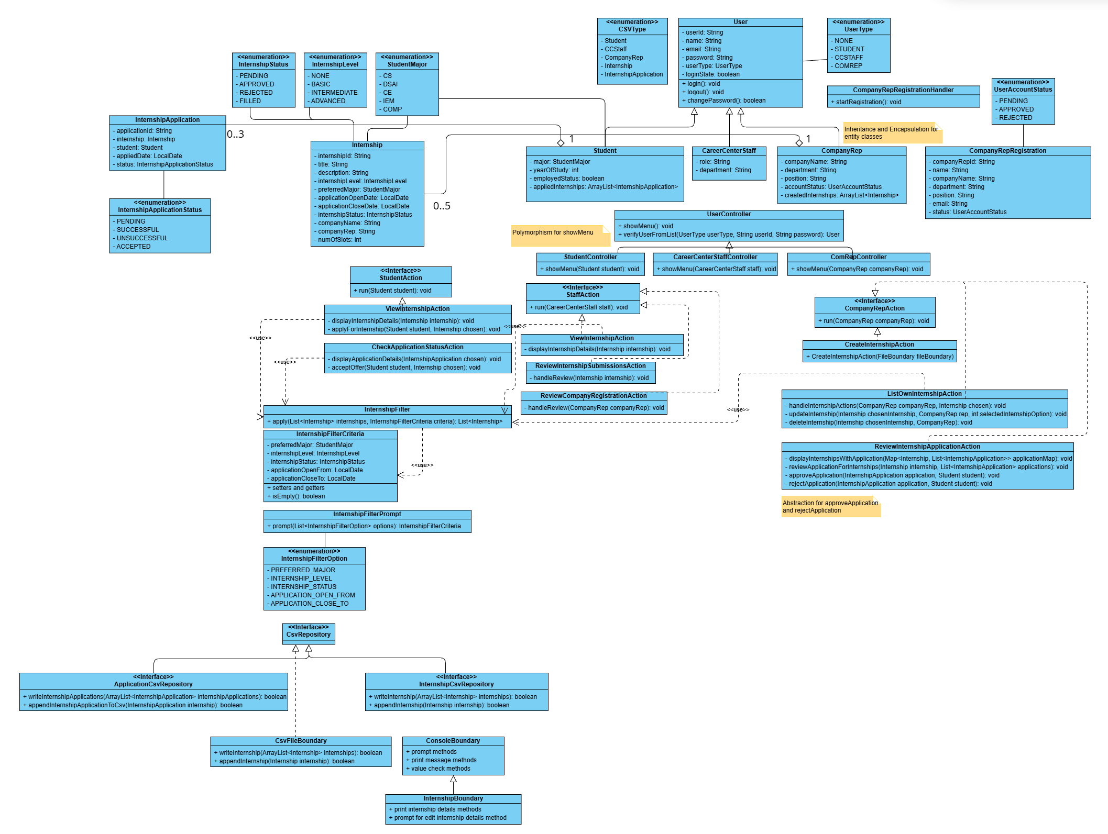

7. Testing/Test cases and results
No. | Test Cases | Expected Behaviour | Failure Indicators
1 | Valid User Login | User should be able to access their dashboard based on their roles | Pass
2 | Invalid ID | System should deny access and alert the user to incorrect password | Pass
3 | Incorrect Password | System should deny access and alert the user to incorrect password | Pass
4 | Password Change  Functionality | System updates password, prompt re-login and allows login with new credentials | Pass
5 | Company Representative  Account Creation | A new Company Representative should only be able to log in to their account after it has been approved by a Career Centre Staff | Pass
6 | Internship Opportunity  Visibility Based on User  Profile and Toggle | Internship opportunities are visible to students based on their year of study, major, internship level eligibility | Pass
7 | Internship Application  Eligibility | Students can only apply for internship opportunities relevant to their profile (correct major preference, appropriate level for their year of study) | Pass
8 | Single Internship  Placement Acceptance per  Student | System allows accepting one internship placement and automatically withdraws all other applications once a placement is  accepted | Pass
9 | Company Representative  Internship Opportunity  Creation | System allows Company  Representatives to create internship  opportunities only when they meet system requirements | Pass
10 | Internship Opportunity Approval Status | Company Representatives can  view pending, approved, or rejected  status updates for their submitted opportunities | Pass
11 | Restriction on Editing Approved Opportunities | Edit functionality is restricted for Company Representatives once  internship opportunities are approved by Career Centre Staff | Pass
12 | Student Application  Management and  Placement Confirmation | Company Representatives retrieve  correct student applications, update  slot availability accurately, and  correctly confirm placement details | Pass
13 | Internship Placement Confirmation Status  Update | Placement confirmation status is  updated to reflect the actual confirmation condition | Pass
14 | Create, Edit, and Delete Internship Opportunity Listings | Company Representatives should  be able to add new opportunities, modify existing opportunity  details (before approval by Career Centre Staff), and remove  opportunities from the system | Pass
15 | Career Centre Staff  Internship Opportunity  Approval | Career Centre Staff can review and  approve/reject internship opportunities submitted by  Company Representatives | Pass
16* | Internship Creation Date Sanity Check | Company Representative can only create internships if their Opening Date is before Closing Date | Pass
*Additional

8. Reflection
Throughout this OODP group project, our team has learnt to apply the theoretical concepts of object-oriented principles such as inheritance, polymorphism, encapsulation and SOLID design principles in developing our program. This knowledge enabled us to properly design and implement an internship system with a well-structured code.
At the start, our main challenge is to design the class diagram and defining the logical flow of the program. We drafted our class diagram clearly and identified which are the attributes and methods that are essential. We also determined which classes should inherit from others. This helped us to appreciate the importance of code reusability and maintainability. We also used a task tracker to see an overview of tasks and track progress so that we can manage our tasks and help one another.
During the implementation phase, we learnt to collaborate effectively, by diving the tasks based on each member’s strengths. For example, one handled the backend logic, another worked on the main program flow and others focused on the testing. Regular discussions and code reviews helped us to communicate clearly and avoid confusion or conflicts. We will share our problem faced with the team members and discuss a feasible solution for it.
Although we faced time constraints, our teamwork, communication and shared commitment helped us to overcome challenges and complete the project successfully. The final product has reflected our collective effort and understanding of object-oriented programming principles.

